Jennifer Stegina

28 August 2019

CIS 250

**Unit 1 Graded Exercise 2**

The following questions come from the “Check your understanding” examples of each section of Chapter 2 in your textbook.

After you are finished, please submit the Microsoft Word file that contains screenshots of the SQL statements and output. **Be sure to include a comment line with your name after each SQL statement.** Your document should be named **U1_GradedExercise2_Lastname.docx**.

(2-12) Question 1:

List the first name, last name, and department code of the employees that have department codes *sal, shp,* and *act*. Do this using an in condition.

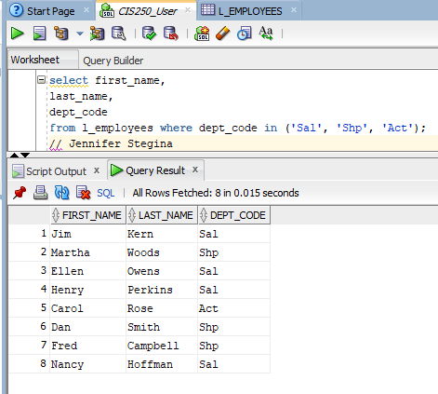

(2-13) Question 2:

List the employee ID, first name, and last name of the employees that have an employee ID between 201 and 205.

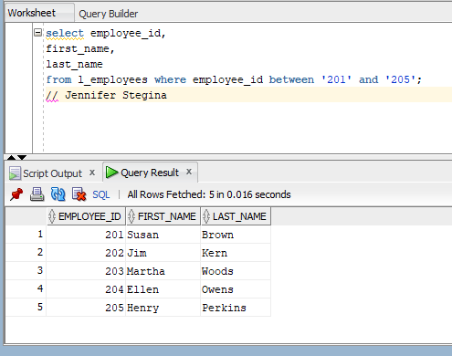

(2-14) Question 3:

List the employee ID, first name, and last name of the employees that have an employee ID that contains a number 1.

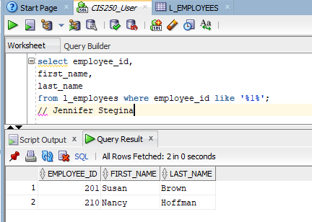

(2-15) Question 4:

List all the columns of the employee table for rows that contain a null in the *manager_ID* column.

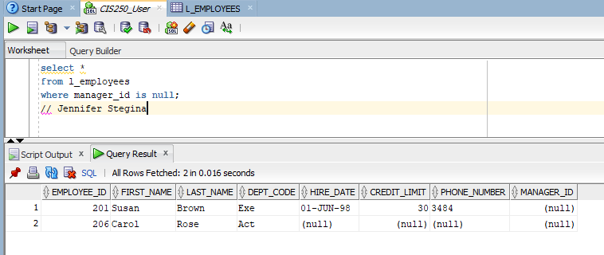

(2-17) Question 5:

List the department name column from the departments table. Give this column a new name of *dept*. Put the rows in ascending order. Write this SQL in two different ways.sal

